Miracle for Mr. Hockey? Family defends stem cell choice
Look, he gets it — the skepticism over what seems to be his father's medical miracle, says Gordie Howe's youngest son.
But Dr. Murray Howe, head of radiology atProMedica Toledo Hospital, also says he knows what he saw: The once-powerful Mr. Hockey — his father — struck mute and unable to walk by a stroke Oct. 26. Who by Dec. 1 "was nearly catatonic."
A family that had accepted his final days. They had made funeral plans.
And a Tijuana medical clinic where, on Dec. 8, the elder Howe sat straight up in bed just hours after an injection of about 100 million stem cells and demanded with an astonishingly strong voice that he needed to use the restroom, Murray Howe said.
"He says, 'I'll walk,' and I said, 'You can't walk,' " Murray Howe recalled. "He says, 'The hell I can't.' And he sits up and puts his feet over the side of the bed and stood up.
"If I hadn't been there and seen that happen with my dad, I don't know if I'd believe it either."
Marty Howe, an older brother, said he was there when it happened again the next day: "When he stood up, we were like, 'This is unbelievable.' "
Fans rejoiced over the Christmastime news of the elder Howe's recuperation following weeks of grim health reports. But doctors were immediately skeptical.
Some called the procedure in Mexico — a two-step injection of two types of stem cells — questionable at best and a scam at worst. They criticized the providers of the procedure for giving the treatment for free to a Hall of Fame legend but charging others $20,000 or more — all in the name of research.
And they have accused Dr. Murray Howe in particular — a doctor trained at one of the nation's most prestigious medical schools, the University of Michigan — of raising false hopes.
"There is no scientific evidence at present that the kind of procedures that he was reported to have received … have efficacy in stroke. That is the bottom line," said Judy Illes, who coauthored a piece for the Vancouver Sun that is featured now on the home page of the International Society for Stem Cell Research.
She's also director of the National Core for Neuroethics and a medical genetics professor at the University of British Columbia.
In the opinion piece, Illes and her coauthor say that companies that offer stem cells to stroke victims "are preying on desperate and vulnerable people and exploiting their hope, much like snake oil salesmen have done throughout most of human history."
Theirs are not the only critical voices.
Dr. David Gorski, a Wayne State University professor and a breast cancer doctor at the Barbara Ann Karmanos Cancer Institute, was among the first to raise red flags, writing about it at the medical blog Science-based Medicine.

DETROIT FREE PRESS
Gordie Howe continues to improve after stem cell treatment

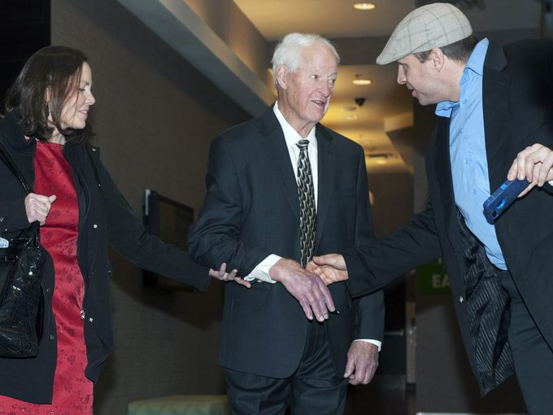
Hockey
The Howes' destination was Tijuana, a region notorious for its "alternative" treatment clinics that the American Cancer Society says have "secrecy requirements" and a track record for patients who die after being told they've been cured.
That reputation is well deserved, said Gorski. "You don't know what you're getting, and they charge a lot of money."
The clinic the Howes went to operated is by Tijuana-based Novastem and supplied with stem cells by San Diego-based Stemedica, which also supplies stem cells to fourclinical trials within the U.S.
Maynard Howe — no relation to the hockey family but now the CEO of Stemedica — argues that research and legitimate clinical trials are conducted all over the world, in countries that have scientifically sound protocols like those in the U.S.
Maynard Howe said Stemedica must comply with rules set by the U.S. Food and Drug Administration governing the production of stem cells and their shipment around the world.
"We're pretty arrogant in the U.S.," he said of the criticism of the Howe procedure. "There are a lot of scientists that think unless the trials were done here (and) unless the FDA gave its blessing, they can't be any good."
Much of the discussion is speculation from both sides, said Henry Ford Health System's Dr. Michael Chopp, whose work has focused on the potential of mesenchymal cells — those often drawn from bone marrow — to help the body repair itself after stroke.
It's wise to be skeptical of "miracle cures," he said, but equally so to not "out-of-hand" dismiss them.
Murray Howe acknowledges: A single anecdote falls far short of scientific proof of cure.
He sat last week in the sunny atrium of Promedica Toledo Hospital as staff, patients and their loved ones passed by.
"All I'm doing is sharing with the world my experience of what I saw with my father," he said.
Just weeks to live
In recent years, age had taken a merciless toll on the 86-year-old hockey great.
Gordie Howe had begun suffering dementia — remembering close friends and family but forgetting what he just had for dinner or which drawer contained the silverware. After wife Colleen's death in 2009, Howe left their Bloomfield Hills home and began to live with his grown children.
His back ached. He lost height. He stopped making public speeches.
On Oct. 26, his daughter, Cathy Purnell, in Lubbock, Texas, found her father on his carpeted bedroom floor, Murray Howe said. He'd had a stroke.
Howe was paralyzed on his right side. He could no longer talk or walk on his own. And although he had a temporary boost — Murray said he was able to get his father to walk 10 steps with a walker one day — the elder Howe continued to slip further and further away.
His once-200 pound frame withered to 170 pounds or so as his ability to swallow deteriorated. His legs were skin on bone, Marty Howe said: "It was like he was turning invisible."
On Dec. 1, Howe was hospitalized again — this time for what most likely was dehydration.
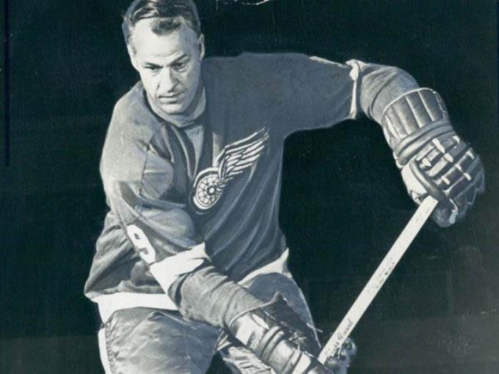
Family members flew in and out. Marty Howe, who lives in Connecticut, said he gave his father just weeks to live.
In Toledo, Murray Howe wrote a eulogy. He said he's acutely aware of life-and-death struggles that sometimes do little more than prolong suffering.
"Our family is about quality of life," he said. "Our father made it clear that he doesn't want to live forever. He just wants to enjoy himself while he's on this Earth."
But at the same time, there was a lingering invitation.
Astonishing turnaround
Around Thanksgiving, Dr. Murray Howe had received a message from Stemedica's Maynard Howe. The CEO had reached out to the family at the suggestion of Stemedica's vice president of marketing, Dave McGuigan, who had once worked for the Red Wings' front office. He knew the Howe family and the elder Howe's condition.
Both Marty and Murray Howe say they were skeptical, but Murray Howe said he was impressed by what he read and by the "confidence" at Stemedica.
"They said, 'You'll see changes in 24 hours,' " he said.
He noted that the company was putting its reputation on the line: If Mr. Hockey died on the table, the world would know about it.
In Texas on Dec. 7, Marty Howe and Cathy Purnell laid their father in the back of a friend's SUV.
Murray Howe met them fresh off a flight from Toledo. He was to provide medical oversight and round-the-clock support, while Marty, a former hockey player himself, was the "beef" to help move the dead weight of their father, Marty Howe said.
Together, Murray Howe said, the brothers "stuffed" their father, nearly unresponsive, into an airplane seat.
They spent the night in a San Diego hotel room provided by Stemedica, the next day loading into a car provided by Stemedica for the 15-minute drive to Tijuana — just across the U.S. border.
That afternoon, as the elder Howe bent forward on a procedure table to expose his lower back, clinicians inserted a 25-gauge tiny needle — as thin as a hair — into his spinal canal, delivering what Murray Howe said was 100 million neural stem cells that would migrate through the spine toward the brain to support the body's healing.
As the day worn on, Murray Howe kept checking his watch, intermittently climbing into his father's bed to comfort and calm him as he grew restless.
Just before 9 p.m., the elder Howe demanded to use the bathroom, Murray Howe said.
It happened again the next morning, when Marty Howe came by.
When his sons tried to stop him, "he used his favorite two swear words. ... He didn't care how it was getting out of bed, he wanted out of bed," Marty Howe recalled with a chuckle.
The next day, Gordie Howe received another dose of stem cells. These were mesenchymal stem cells, delivered intravenously, to support for new tissue growth, Stemedica officials said.
Murray Howe, who insists the family has not been paid to promote the treatment, said the family has been so astonished at their father's turnaround, family members have since invested in Stemedica.
"I've been doing medicine for 28 years. I've never seen anything like that," he said.
Other explanations?
Skeptics of the treatment are quick to point out that they wish the elder Howe the best. But they also list a number of other possible reasons for the elder Howe's rally: Rehydration, the body's natural ability to repair itself after stroke, and a placebo effect that renews a will to live.
It's impossible for other researchers to look at the data to tease out any benefits from stem cells or even to detect what risks there may be because the procedure doesn't fall under the type of transparency demanded by the FDA, said Jack Parent, a neurology professor at U-M.
"Here, we're left with hearsay in terms of how much he recovered," he said.
Gorski, who was at U-M about the same time Dr. Howe was training, is quick to note that he's a breast cancer doctor, not a stem cell expert. But he said he does the scientific and ethical rigor demanded of legitimate research. This procedure falls far short and could be downright dangerous, he said.
"I'm not questioning (Murray Howe's) account that his father is doing much better. ...I'm questioning the inference that (the cause) is stem cells."
Stemedica's Maynard Howe says the company has sent e-mails to critics, offering them details on the procedure and inviting them to the clinic. Not one has taken them up on the invitation, he said.
To be clear, age continues to take its toll on the elder Howe. He still has dementia. He's slow. He sleeps most of the day, said Marty Howe, who traveled to Lubbock last week to be with his father and sister.
On Monday, as he spoke to the Free Press by phone, Marty Howe said he could see his father and a caregiver walking the sidewalk outside his window. And the skepticism? He echoes his brother. He can only say what he saw and what he sees today.
"I truly believe if he didn't get that stem cell treatment, he would not be with us. ... He looks great. He's not going to win any races, but he's steady and on his feet."

